Year 2 Home learning: WB 30.11.20
This is your child’s learning for the week where you can access the different learning on each day. If you need any assistance, please contact your child’s class teacher. Most of the learning is accessible on any device with the internet and you will need a device to access ‘Zoom’ (either by website or by browser.)
The blue text can be clicked on to take you straight to the website/webpage where there are videos and the learning expected. Please complete learning in a home learning book provided by school or on paper and then upload this to See-Saw so that your teacher can see it and respond to it.
Day of the week. | VALUES | Number bonds practice | Maths Learning (WR)  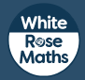 | Activity breaks |  | Reading | Phonics | English (writing) Live lesson | Wider curriculum + RE
Monday | Show our value of the month –UNITY and record it in your values passport or in your home learning book. | Practice your numbers bonds using the awesome game “Hit the Button” – click the link to go straight to the website J  Focus on 0-10  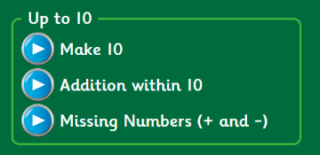  Move on to 0-20  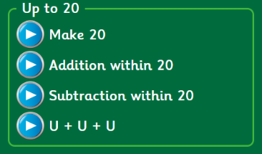  There are more challenges on there…up to 100!  Good luck! | Hit the Button | Joe Wicks 5 minute exercise part 1: | AND/ OR  Set a timer and:  Jog on the spot for one minute.  Do as many press-ups as you can in one minute.  Do as many star jumps as you can in one minute.  Do as many squats as you can in one minute. | Choose a book from home to read. Draw a picture and write 3 sentences about what you’ve read. | ng and nk | Daily lesson:  11:00-12:00  Your zoom link and password will be sent in a separate email.  Please arrive promptly to start with your resources ready  Your child will be able to access the same link each day at the same time for their live lesson. | Geography – Where are the world’s people? Lesson 1
Tuesday |  |  | Money – recognising coins and notes. | Joe Wicks 5 minute exercise part 2: |  |  | r and wr |  | R.E. – What is the Christmas story? Lesson 1
Wednesday |  |  | Money – counting pence | Cosmic kids Yoga: |  |  | s, c and sc |  | PSHE – Helpful but harmful  Lesson 4
Thursday |  |  | Money – counting pounds and pence | Joe Wicks 5 minute exercise part 3 : |  |  | Alien words |  | Science – How can you measure rainfall? Lesson 4
Friday |  |  | Select money | Cosmic kids Yoga: |  |  | tion |  | Music – Pulse - Lesson 4

